Chanakya University
School of Engineering



Assignment – 2

Week 1 & 2 Report
Introduction to AIML

Submitted By:

Harshitha P
24UG00551
B Section
(CSAI)

Objective:
In week 1, the main aim was to collect and organize a complete dataset of historical FIFA World Cup information from reliable sources, which would be used later for modeling. This included gathering detailed team and player statistics, match results, and advanced performance metrics. Once the data was collected, it was cleaned and integrated—removing errors, filling gaps, and structuring it properly—so that it could serve as a solid foundation for further analysis and predictive modeling.

Data Source:
For this project, I used several trusted sources to collect historical FIFA World Cup data:

FBref:
Provides historical match and team statistics, such as wins, losses, goals scored, and goals conceded. This data helps understand past team performance and patterns, which is essential for predicting how teams might perform in future tournaments.

Transfermarkt:
Offers player and squad information like average age, international experience, and market values. These features are important because experienced and high-value players often contribute more to team success, making it a strong predictor for outcomes like reaching the finals.

SofaScore:
Supplies advanced metrics and player ratings for individual matches. These insights capture the quality of team and player performances beyond simple goals and wins, allowing models to account for factors like consistency, form, and overall contribution to team success.

The Analyst:
Provides historical statistical analysis and advanced metrics. This helps validate and enhance the dataset, offering additional predictive insights such as trends, team strengths, and performance indicators that can improve model accuracy.
By combining these sources, we can capture both team-level performance patterns and player-level quality, which together provide a strong foundation for predicting which teams are most likely to reach the finals

Methodology:
The data was collected from trusted sources like FBref, Transfermarkt, SofaScore, The Analyst, and Kaggle. FBref provided match and team statistics through simple tables, while Transfermarkt required more advanced scraping because some data was loaded dynamically. SofaScore gave player ratings and advanced stats, The Analyst offered historical insights, and Kaggle provided ready-to-use datasets that helped speed up data collection. After gathering all the information, it was cleaned, organized, and combined into a single dataset ready for analysis and modeling.

Tools Used:

Python was used to collect and process the data, along with these key libraries:
requests : to fetch web pages from the sources.
BeautifulSoup : to read and extract data from HTML tables.
pandas : to clean, organize, and manage the dataset.
time and logging : to handle delays between requests and track any errors.

Code:
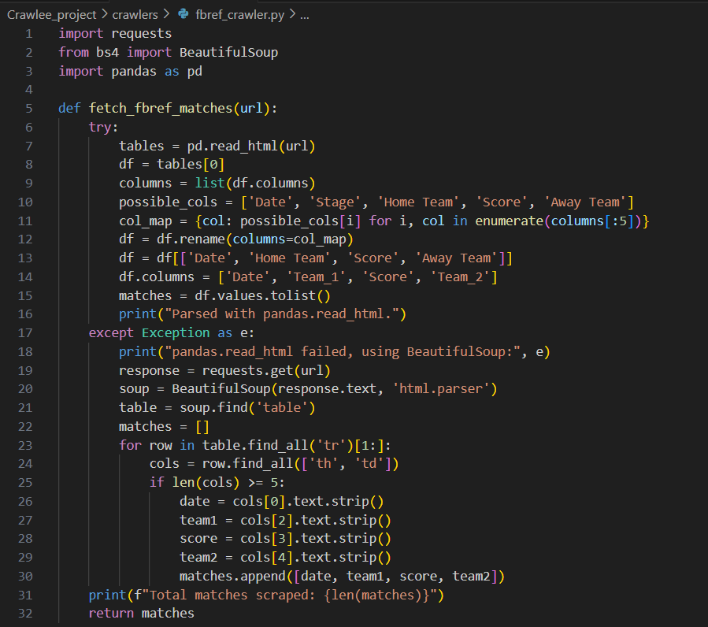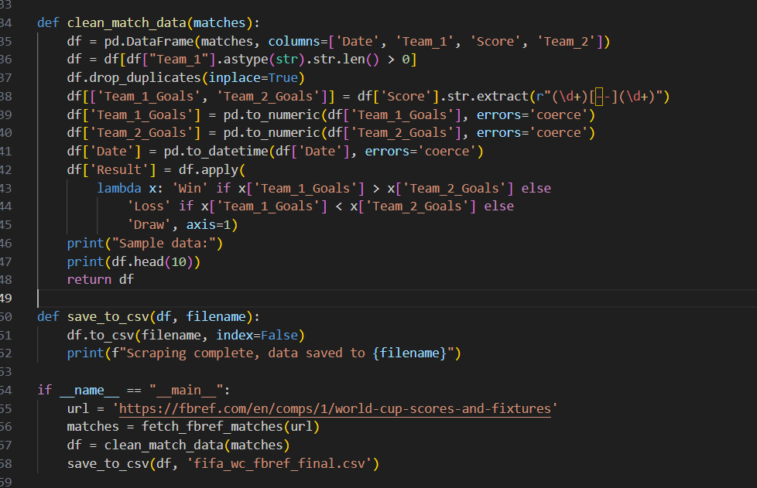

Progress and Achievements:
- Successfully collected over 130 team records from FBref, including key statistics like goals scored, shots, and possession.
- Extracted player and squad-level data from Transfermarkt, despite some challenges with dynamically loaded content.
- Started combining different datasets and began standardizing information, including fixing inconsistencies in team names (for example, “Côte d’Ivoire” vs “Ivory Coast”).
- Documented all scraping scripts thoroughly, including comments about errors encountered and how they were resolved.

Next Steps:
- Learned that some sources require more advanced scraping techniques, such as using browser automation or exploring APIs.
- Plan to improve the completeness of the dataset by cross-checking with alternative sources like SofaScore, The Analyst, and Kaggle.
- The next phase will focus on thorough data cleaning and advanced feature creation, including calculating goal differences, recent performance trends, team average age, and other metrics that can improve prediction accuracy.

WEEK – 2
Preparing Data and Building Models:

Data Preparation
- Loaded the cleaned FIFA World Cup dataset into Python using pandas.
- Filled missing numerical data using median values and labeled missing categorical data as unknown.
- Converted dates into proper date format for analysis over time.
- Created new features to improve prediction, such as goal difference and recent win rate, which help the model understand team performance trends.
- Split the dataset into 80% training and 20% testing to evaluate model accuracy reliably.
- Scaled numerical features and encoded categorical features like confederation to make them suitable for modeling.

Model Building:
- Logistic Regression: Used to estimate the probability of a team reaching the finals.\

- Random Forest Classifier:
Captured complex patterns in the data, such as interactions between player experience, team stats, and recent form.
Both models were trained on the prepared dataset and tested on the holdout set to see how well they could predict which teams would become finalists.
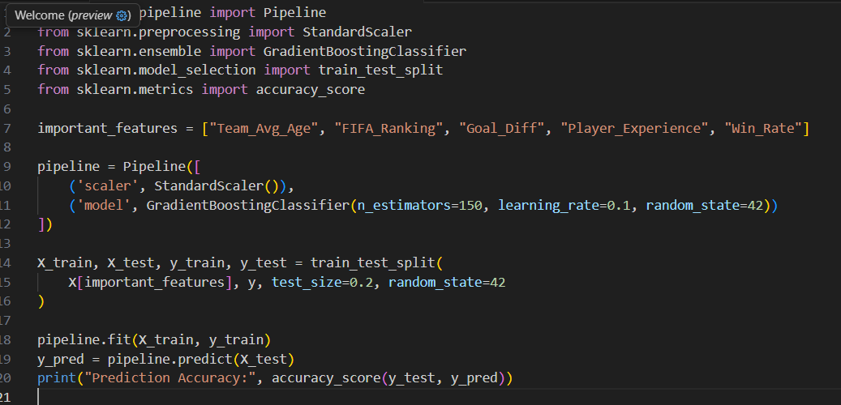
Data Preprocessing :
Data Import:
import pandas as pd df = pd.read_csv('merged_worldcup_data.csv')

Handling Missing Data:
Used median imputation for numeric values. o Filled missing
categorical fields with unknown

Feature Scaling:
Applied StandardScaler() to normalize numerical attributes

Encoding:
Used LabelEncoder() for categorical columns like confederation.

Train–Test Split
80 % training, 20 % testing using train_test_split(random_state = 42).

Model Development:
- Random Forest Classifier
- Logistic Regression

Important Learnings from Modeling:
- Having clean and complete data is very important — missing information like player stats or expected goals can lower the accuracy of predictions.
- Certain features, such as FIFA ranking, goal difference, and recent win rate, are more valuable for predicting finalists than just counting total goals.
- Using pipelines and modular code makes preprocessing and modeling organized, repeatable, and easier to manage.
- Understanding the game and the importance of different statistics helps improve the model’s ability to predict which teams are likely to reach the finals.

